Introduction to Second Life Viewer 1
by
Graham Davies

This document can be downloaded from the ICT4LT website at
http://www.ict4lt.org/en/Euro08PCWSL.doc

This document is a set of tutorial materials for Second Life Viewer 1 that I have used in several workshops for newcomers to Second Life, including the pre-conference workshops at the EUROCALL 2008 and EUROCALL 2009 conferences. I have recently completed a similar set of materials for Second Life Viewer 2, which replaces Second Life Viewer 1.

The Viewer 2 materials are available from this location at the ICT4LT site:
http://www.ict4lt.org/en/IntroSLViewer2.doc

Feedback on these tutorial materials is welcomed. Please let me know if you find mistakes or anything that is unclear or not covered. I can be contacted via the feedback form that can be found at the foot of every page at the ICT4LT website:
http://www.ict4lt.org

Revised 1 April 2010

Introduction to Second Life Viewer 1 by Graham Davies 1
1. Essential preparatory reading 3
2. Registering as a member of Second Life 3
2.1 Logging in 3
3. Installing QuickTime 4
4. The EUROCALL/CALICO HQ – a meeting place 4
5. Communicating 6
5.1 Text Chat 6
5.2 Contacts: Friends and Groups 7
5.3 Friends 7
5.4 Groups 8
5.5 IM/CALL 8
5.6 Voice Chat 9
5.7 Muting annoying avatars and stalkers 10
5.8 Further tutorial materials on communicating in Second Life 10
6. Movement Controls and Camera Controls 11
6.1 Moving around: walking, running, flying, sitting 11
6.2 Alternatives to using the Camera Controls 12
6.3 If you lose sight of your avatar… 12
6.4 Following another avatar 12
7. Mouselook 12
8. Tour of the Second Life screen 12
8.1 Main Menu at the top of the SL screen 13
8.1.1 File menu 13
8.1.2 Edit menu 13
8.1.3 View menu 14
8.1.4 World menu 14
8.1.5 Tools menu 14
8.1.6 Help menu 14
8.1.7 Advanced menu 14
8.2 Buttons at the foot of the SL screen 14
9. Tour of the EUROCALL Building: Lower Lounge 15
10. Presentation screens in the EUROCALL Building 17
10.1 Image viewing screens 17
10.2 Video viewing screens 18
11. Listening to streamed audio 18
12. Accessing a website within Second Life 19
13. Your Inventory 19
14. Buying objects 20
15. Notecards: creating Notecards 21
16. Navigation: World Map, Mini-Map, Landmarks 21
16.1 World Map 21
16.2 Mini-Map 22
16.3 Landmarks 23
17. Searching 23
18. Changing your appearance 23
19. Taking snapshots 24
20. Building and editing objects in a sandbox 25
21. Vehicles 25
22. Holodecks 26
23. Giving things to other avatars 27
24. SLURLs 27
24.1.1 What is a SLURL? 27
24.1.2 How do I create a SLURL? 28
25. Further tutorial materials 28
26. Copyright 29

1. Essential preparatory reading
Before you work your way through these notes you are strongly advised to read these two sections of Module 1.5 at the ICT4LT site, which will give you introductory information and links that you can follow up:

- Module 1.5, Section 14.2 Chat rooms, MUDs, MOOs and MUVEs:
http://www.ict4lt.org/en/en_mod1-5.htm#14.2

- Module 1.5, Section 14.2.1 Second Life:
http://www.ict4lt.org/en/en_mod1-5.htm#secondlife

2. Registering as a member of Second Life
First you need to register as a member of Second Life – usually abbreviated to SL.

Click on Join Now at http://secondlife.com

You begin by giving your real-life contact details and then choosing
- your avatar’s first name,
- your avatar’s second name,
- your Second Life password,
- your starting look (i.e. your avatar’s appearance) from a set of images that show what you will look like in Second Life.

Finally, fill in the security check boxes and agree to the terms of service.

You can choose your first name freely but you have to pick your second name from a list of available names. Choose carefully, as once you have set up your Second Life account you cannot change your name. Each chosen name in SL is unique and you retain your name until you close your SL account.

Don’t worry if the starting look of your avatar is not what you would like it to be. You can change everything once you have entered Second Life: your body shape, your skin colour and texture, your hair, your clothing – and your can choose whether you want to look like a male or female person or even a bird or an animal! You will find more information on Changing your appearance in Section 18.

Confirmation of your registration will be sent to your email address so that you can activate your account, download the SL software to your computer and install the Second Life Viewer – which is a sort of sophisticated browser that enables you to move around SL and interact with people you meet.

2.1 Logging in
Once you have activated your SL account and have downloaded the SL software and installed the SL Viewer you can log in. Click on the Second Life icon on your desktop, enter your chosen avatar name and your chosen password, and then click on Log In. See Figure 1 (p. 4), which shows a typical login screen.

On your first visit you will be taken to a welcome area, which teaches you basic SL skills and concepts. There are many areas in SL that offer you help in learning the skills that you need in order to move around, chat to people, change your appearance, etc. These are known as Help Islands or Orientation Islands, and you can visit them whenever you wish.

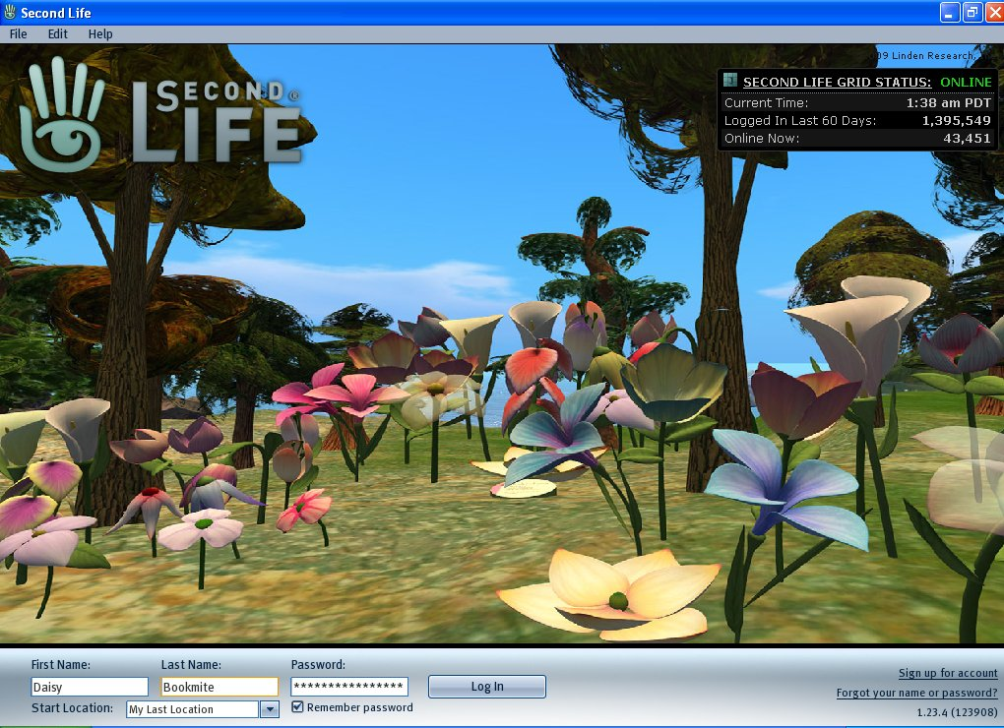

Figure 1: A typical Second Life Login Screen

3. Installing QuickTime
You must have QuickTime installed on your computer if you wish to display slide shows and videos in Second Life. QuickTime is available at this website:
http://www.apple.com/quicktime/download/

4. The EUROCALL/CALICO HQ – a meeting place
There are numerous locations in Second Life where you can meet people. We normally use the joint EUROCALL/CALICO Headquarters as a meeting place for participants wishing to take part in introductory workshops and tours. The joint HQ is located on one of the EduNation Islands, a group of three islands managed by The Consultants-E and dedicated to promoting SL as an educational environment, especially for language learning and teaching: http://www.theconsultants-e.com

The easiest way to locate the HQ, which is on EduNation III Island, is to click on the following SLURL or to copy and paste it into your Web browser’s address box:
http://slurl.com/secondlife/EduNation%20III/31/34/22

SLURL stands for Second Life URL, which is to SL what a URL is to a Web browser, namely an indication of a location in Second Life: see Section 24 below.

When you paste the above SLURL into your Web browser’s address box this will open the Second Life website and invite you to teleport to the above location, the Welcome Pavilion of the joint HQ. If you accept the invitation to teleport, the Second Life Viewer installed on your computer will open, inviting you to log in, and you will then be teleported directly to the Welcome Pavilion. The concept of teleporting is crucial in Second Life. Essentially, it is a way of quickly moving around in Second Life from one location to another.

Once you understand the basics of moving around in SL, you can start the SL software, log in as indicated in Section 2.1 and then make your own way to the HQ on EduNation III Island, as shown on the World Map below – see the You icon at the bottom left of the top island. In Section 9 we will begin a Tour of the EUROCALL Building, and in Section 16 we will be looking at Navigation, the World Map and the Mini-Map in more detail.

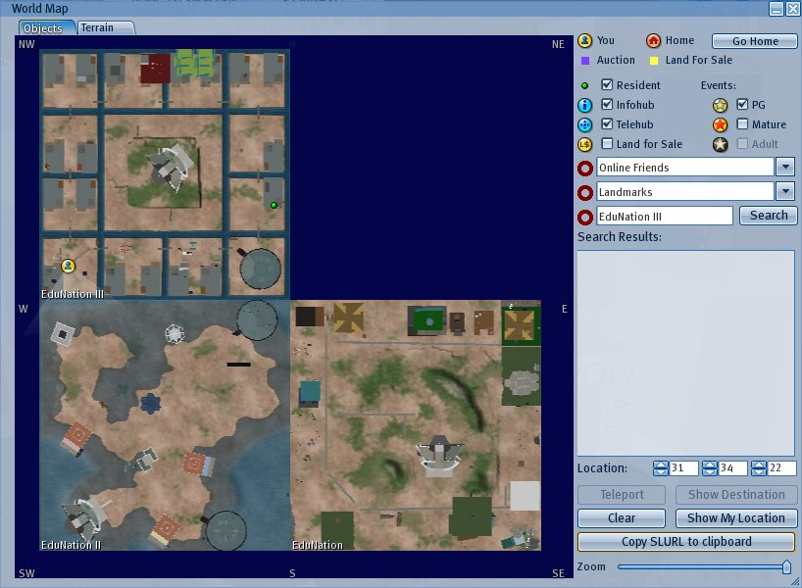

Figure 2: Location of the EUROCALL/CALICO HQ

The EUROCALL Building on the joint HQ site is the home of EUROCALL and right next door you will find the home of CALICO. CALICO is EUROCALL’s sister association in the USA. Both associations have enjoyed a long period of collaboration and now they have joined forces and set up a joint EUROCALL/CALICO Virtual Worlds Special Interest Group (VW SIG): http://virtualworldssig.ning.com

The EUROCALL Building is managed by myself, Graham Davies (Groovy Winkler in SL). CALICO’s home is managed by Randall Sadler (Randall Renoir in SL). We are now in the process of creating a set of facilities that will be available to language teachers and students from all over the world. Further information and a guide to the facilities can be found in the Welcome Pavilion. In the Welcome Pavilion you will find:

- a cube which will deliver information about the two associations to you;
- two teleporters, which appear as small circular pads on the ground – one of these enables you to move quickly around the joint HQ, and the other one enables you to move around the whole of the island on which the joint HQ is located;
- a notice board describing the locations in the joint HQ that can be accessed via the internal teleporter system;
- information on using the holodeck – we will be looking at holodecks later in this tutorial: see Section 22.

Teleporters are very useful as they enable you to move around very quickly, rather like the transporters in Star Trek. We will be looking at teleporters again in our Tour of the EUROCALL Building, beginning in Section 9.

5. Communicating
We first need to learn how to communicate with one another in SL. There are three main ways of communicating:

- Text Chat
- IM (Instant Message)
- Voice Chat

5.1 Text Chat
If you wish to engage in Text Chat with people around you, click on the Speech Bubble button at the bottom left of the SL screen:

Figure 3: Speech Bubble button

This will open the Local Chat box:

Figure 4: Local Chat box

Type whatever you wish to say in the box to the right of the Local Chat button and then click on Say – or just press the Enter key on your keyboard. Your message will appear on the screen, and any replies to your message from people around you will also appear. If you wish to keep track of what is being said, click on the Local Chat button and the full text of recent chat (the Chat History) will appear in a pop-up window. You can use the entry box at the foot of this window to continue entering your chat messages. URLs that appear in Chat History are clickable. If you click on a valid URL, a Web browser window will open, displaying the Web page of the URL.

If you wish to keep a copy of a text chat conversation you have had, you can copy it by using the standard Windows procedure of marking the text by clicking and dragging the section you want to keep and then pressing CTRL + C. You can paste the text into another application by pressing CTRL + V – just as you would do in Word, for example.

There is also a way of saving a log of your text chat sessions automatically to your computer’s hard disk:

- Select Edit > Preferences from the Main Menu. This will cause the Preferences menu to pop up.
- Click on the Communication button in the left-hand column of the pop-up menu.
- Check the box labelled Save a log of Local Chat on my computer.
- Click on the Change Path button.
- In the box next to the Apply button enter the name and location of the folder on your computer’s hard disk where you would like the Chat History to be stored, e.g. in the Temp folder or your personal folder.
- Click on the Apply button at the foot of the pop-up menu.
- Close the Preferences menu by clicking OK at the bottom.

After you have logged off Second Life you should find your Chat History stored in your chosen folder under your avatar name.

You will notice that there is a Gestures button to the right of the Local Chat box. Experiment!

5.2 Contacts: Friends and Groups
As you explore SL you will make lots of new contacts. Click on the Local Chat button and select the Contacts tab at the foot of the Communicate pop-up window. You will see two tabs: Friends and Groups. Alternatively, click on the Communicate button at the bottom left of the SL screen.

5.3 Friends
The Friends tab in the Communicate pop-up window displays a list of your friends in SL. The quickest way of offering friendship to someone and adding them to this list is to right-click on their avatar on screen and then choose Add Friend from the pop-up pie menu. If your offer of friendship is accepted by them, their name will be added to your Friends list.

You can also click on Add in the Friends window if you wish to add a new friend. A new window asking for the resident’s name will pop up. You can now search for the name of someone you know in SL by entering their name or just part of their name in the search box and then clicking on Find. If their name appears in the window click on it and then click on Select. This will cause an Add Friend window to appear. Click on OK and a message will be sent to the person offering them friendship. NB: Be careful how you use this facility; you should offer friendship only to people whose avatar names you already know.

Friends who are online appear in bold in the Friends list .You can invite them to join you in your current location by clicking on their name and then clicking on the Teleport button. But always consider your friends' privacy; they may be busy in another location.

You can use the World Map to track your friends' whereabouts in Second Life: see Section 16 on Navigation. To track a friend, type his/her name into the Online Friends menu of the World Map. If your friend is online and has allowed you to see his/her location, he/she will appear on your map as a red destination marker.

NB: Your friend must grant you the ability to see his/her SL location before you can track him/her using the World Map. To let someone see you on the World Map, highlight their name in the Friends list and check the icon at the top of the list labelled Friend can locate you on the map.

It is possible to teleport directly to a friend's location by pressing the Teleport button once you have located them. Again, you should always remember to consider your friends' privacy; teleporting to someone's location unannounced is considered very impolite!

5.4 Groups
The Groups tab in the Communicate pop-up window displays a list of groups to which you belong in SL, for example the EUROCALL group. You can search for groups by clicking on the Search button at the bottom of the SL screen, entering the group’s name or part of its name, e.g. EUROCALL. Click the name of the group and then click on View Full Profile. Under the group’s logo there is an invitation to join the group for L$0, i.e. zero Linden Dollars, Second Life’s currency – see Section 14. Click on Join to become a member of the group, and you will find that the name of the group will now appear in your Groups list. Some groups allow you to join only by invitation from the group management.

5.5 IM/CALL
Local Chat is normally used for chatting to anyone that is near you, and everyone can see what you type. You may, however, wish to contact people who are not in the same location as you or who are not online at the same time as you. Click on the person’s name in your Friends list and then click on the IM/CALL button = Instant Message/CALL. This will open a window in which you can engage in private chat (i.e. no else can see it) and also to send your friend a message if they are offline. If your friend is online anywhere in SL they will receive your message. If they are offline the message will be stored and delivered to them later.

See this YouTube SL tutorial on Friends and Groups:
http://www.youtube.com/watch?v=8yCS5RgkfOE

5.6 Voice Chat
As well as communicating with people in Text Chat, i.e. by typing at the keyboard, you can also communicate using Voice Chat. If you wish to use Voice Chat to speak to people around you, you need to connect a headset comprising earphones and a microphone to your computer. You also need to check that you have activated Voice Chat in the Edit / Preferences menu: see Section 8.1.2. The default settings should have automatically activated Voice Chat when you registered with SL.

Voice Chat is not available in every location in SL. If it is available then you will see a white dot above your avatar’s head.

If you wish to talk to someone nearby, click on the Talk button at the bottom right of the SL screen to activate your microphone: see Figure 5 below. You should then see green waves emanating from the white dot, indicating that your microphone is active. If you wish to see who is using voice chat around you, click on the button showing the image of two people talking, immediately to the left of the Talk button: see Figure 5 below. This will display a list of active speakers in a pop-up window. You can adjust the volume of the voice of an individual speaker near you by clicking on the speaker’s name and then adjusting the volume control at the bottom of the pop-up window. Switch off your microphone by clicking on the Talk button again.

You can adjust the level of the sound that you hear through your headphones by clicking on the Volume Control icon (loudspeaker): see Figure 5.

Figure 5: Audio, Video, Volume Control and Talk buttons

The Audio icon (music crotchet) is explained in Section 11 and the Video icon (movie camera) is explained in Section 10.2.

See these video clips for more information about Voice Chat:

- http://wiki.secondlife.com/wiki/Voice_Mentors:_Getting_Started_with_Voice

- What is that white dot over my head?
http://lindenlab.blip.tv/file/1105712/

If you click on the up-arrow to the right of the Volume Control icon (loudspeaker) a pop up menu will appear that enables you to control the volume of the variety of sounds that you hear in SL:

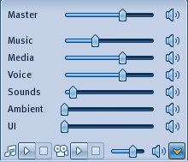

Figure 6: Individual sound controls

- Master refers to the general level of sound.

- Music refers to the level of sound of background music played in SL locations.

- Media refers to the level of sound of video recordings.

- Voice refers to the level of sound of your voice.

- Sounds refers to a variety of background sounds you hear in SL, e.g. birds singing, wolves howling, etc.

- Ambient refers to sounds such as the wind, waves breaking on a shore, etc.

- UI stands for User Interface. I always turn this down as it produces annoying clicks whenever I use my mouse.

5.7 Muting annoying avatars and stalkers
Yes, unfortunately annoying avatars and stalkers do exist in Second Life. You may find yourself engaged in conversation with someone who you would rather not talk to. Women avatars in particular often experience unpleasant encounters in which they are approached by a male avatar who begins to make suggestive remarks. But Second Life is more convenient than Real Life if this happens to you. You simply right-click on the annoying avatar and choose Mute from the pop-up pie menu. And that’s the last you will hear from them, unless you choose to Unmute them, which you can do by selecting View from the main menu bar and removing their name from the Mute List.

5.8 Further tutorial materials on communicating in Second Life
Nergiz Kern (Daffodil Fargis in SL) has produced an excellent set of video tutorials on communicating in Second Life. They can be found in her blog, Teaching in Second Life:
http://slexperiments.edublogs.org/2009/11/15/how-to-communicate-in-second-life/

6. Movement Controls and Camera Controls
The current edition of SL displays Movement Controls, which are initially located at the foot of the SL screen, and Camera Controls, which are initially located at the top of the SL screen: see Figure 7.

The Movement Controls enable you to control your movements around your immediate environment: moving forwards, backwards, turning right and left and jumping up and down. The arrows are more or less self-explanatory – try them and see what happens. There is more information about moving around in Section 6.1 (next section).

The Camera Controls enable you to view your environment from different angles and at varying distances. The circle on the left enables you to rotate the SL screen, the plus/minus bar in the middles enables you to zoom in and out, and the circle on the right enables you to pan left and right and up and down. Experiment!

Bots sets of controls can be moved around the screen by dragging them with the mouse, or they can be turned off and on in the View menu.

 | 
Movement Controls | Camera Controls

Figure 7: Movement Controls and Camera Controls

6.1 Moving around: walking, running, flying, sitting
- Walking: You can move around your SL environment either by using the onscreen Movement Controls (see Section 6 above) or by using the arrow keys on your keyboard:
  - up-arrow (go forwards)
  - down-arrow (go backwards)
  - right-arrow (go right)
  - left-arrow (go left)

- Running: If walking is too slow for you double-click the up-arrow key in order to run. You can also select World / Always Run from the Main Menu bar.

- Flying: If you wish to fly, click on the Fly button at the foot of the SL screen or select World / Fly from the Main Menu bar. Use the Page Up and Page Down keys on your keyboard and the Movement Controls or arrow keys on your keyboard to fly around. Click on the Stop Flying key at the foot of the SL screen to stop flying. Don’t try flying indoors unless you are in a very large building! In some areas of SL flying is forbidden, and then the Fly button will not work.

- Sitting: You can sit on all sorts of objects in SL. If the object, e.g. a chair, is meant to be sat on, a chair icon will appear when you move your mouse over the object. Click on the object and your avatar will sit on it. To stand up, simply click on the Stand Up button that will appear at the foot of the SL screen. Alternatively, you can right-click on the object and then choose Sit here from the pop-up pie menu. See this SL tutorial video:
http://lindenlab.blip.tv/file/1105689/

- Swimming: It is even possible to swim in SL. In many beach areas in SL you will sea swim balls in the sea. If you fancy a swim just click on a swim ball. There may also be boats nearby in which you can cruise around: see Section 21 on Vehicles.

6.2 Alternatives to using the Camera Controls
- Hold Alt and move the mouse left and right to change your view of your environment, or move the mouse forwards and backwards to zoom in and out.

- You can also use your mouse’s scroll wheel to zoom in and out: see this video clip: http://www.youtube.com/watch?v=8ApPoe1pdac

- Hold Alt and Ctrl and move the mouse forwards and backwards to look up and down.

6.3 If you lose sight of your avatar…
Newcomers to SL often find that they lose sight of their avatar. This can easily result after a few minutes of using the Movement Controls and Camera Controls. The solution is simple: just press the Esc key on your keyboard twice and the camera (your view of the screen) will home in on your avatar.

6.4 Following another avatar
Sometimes you may wish to follow another avatar, for example in a situation when a teacher or a friend is showing you around. It is very easy to lose track of another avatar – in the same way as you can lose sight of your own avatar. Again, the solution is simple: to avoid losing track of another avatar, hold down the Alt key on your keyboard and left-click with your mouse on the avatar you wish to follow. This causes the camera (your view of the screen) to home in on the avatar you wish to follow, even when s/he moves around. See also Section 5.3, which tells you locate a friend on the World Map.

7. Mouselook
Mouselook enables you to look around your environment by moving your mouse. Select Mouselook from the View menu to start Mouselook. Move your mouse around to see what happens. The camera (your view of the screen) will pan left, right, up and down according to the directions in which you move your mouse. Press the Esc key on you keyboard to cancel Mouselook.

8. Tour of the Second Life screen
Now we will take a look at the important items of the menus on the SL screen (Figure 8 below).

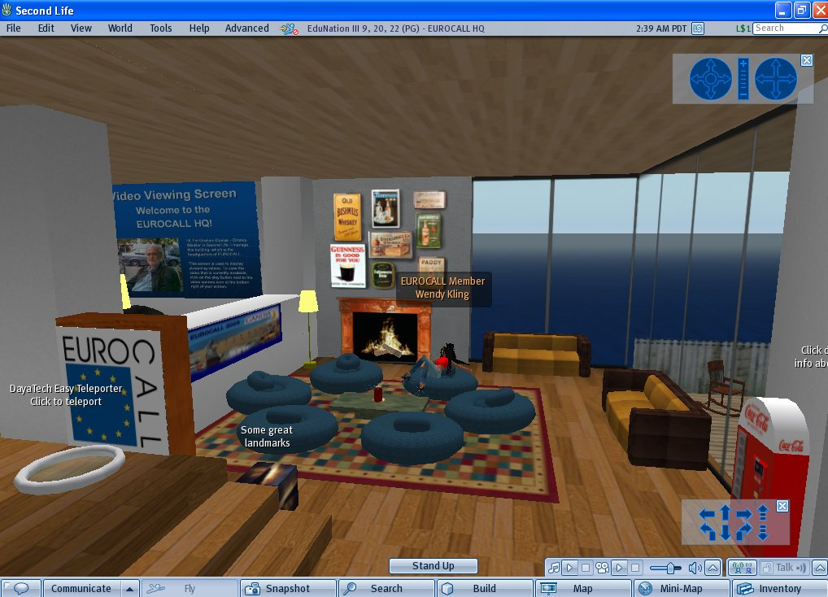

Figure 8: Second Life screen, showing the EUROCALL lounge

8.1 Main Menu at the top of the SL screen
The Main Menu bar, located at the top of the SL screen, with its seven sub-menus, looks a bit daunting at first sight:

Figure 9: Main Menu bar

However, there are only a few of the sub-menu items which need concern you for the moment, namely:

8.1.1 File menu
- Take Snapshot – see Section 19
- Snapshot to Disk – see Section 19
- Quit – quit Second Life

8.1.2 Edit menu
There are several important items here, but for the moment we will concern ourselves only with the last one on the list: Preferences. Most of your preferences are best left at their default settings, but these settings may need to be confirmed. Click on Preferences and you should see a pop-up window containing the following choices. There are other choices, but for the moment these are the important ones that concern you:
- General
  - Start Location – select My Last Location.
  - Language – choose your preferred language.
- Web – select Use built-in web browser.
- Audio & Video – if you wish to be able to play audio and video in SL, ensure that the Play Streaming Music and Play Streaming Media boxes are checked. Leave the Automatically play media box unchecked.
- Voice Chat – make sure that Enable voice chat and Hear Voice Chat from camera position are checked. Otherwise, keep the default settings.
- Skins – select Silver for the screen display; it looks nicer!

8.1.3 View menu
- Mouselook – see Section 7
- Camera Controls – see Section 6
- Movement Controls – see Section 6

8.1.4 World menu
- Always Run – when this option is checked your avatar will run rather than walk. See Section 6.1.
- Fly – when this option is checked your avatar will fly. See Section 6.1.
- Create Landmark Here – see Section 16.3.
- Environment Settings – to set time of day. Set this to Midday, otherwise the screen may appear too dark. On the other hand, you may like the more romantic settings Sunrise or Sunset.

8.1.5 Tools menu
For the moment this menu need not concern you. It’s for more advanced users.

8.1.6 Help menu
Choosing Second Life Help causes a pop-up Web browser window to appear, opening the SL website Help page. This is also accessible by pressing the F1 key.

8.1.7 Advanced menu
This is a menu that is normally hidden. It’s strictly for the techies and can be made accessible by pressing Ctrl + Alt + D. This YouTube SL tutorial explains the Advanced menu:
http://www.youtube.com/watch?v=IrndvDk-pzY

8.2 Buttons at the foot of the SL screen
The Audio, Video, Volume Control and Talk buttons that appear at the bottom right of the SL Screen are dealt with in the following sections:

- Audio icon (music crotchet) – see Section 11
- Video icon (movie camera) – see Section 10.2
- Volume Control icon (loudspeaker) – see Section 5.6
- Talk – see Section 5.6

Now let’s look at the remaining buttons at the foot of the screen – from left to right:

Figure 10: Buttons at the foot of the SL screen

- The Speech Bubble icon, bottom left, toggles:
  - Local Chat – which will display the box where you enter text that you wish to send to others around you, either by pressing the Enter key on your keyboard or by pressing the Say button: See Section 5.
  - If you click on the Local Chat button you can display Chat History and also your personal list of Contacts (Friends and Groups): see Section 5.2.

- The Communicate button will also display Chat History, as well as your personal list of Contacts (Friends and Groups) – see Section 5.2.

- Fly – see Section 6

- Snapshot – see Section 19

- Search – see Section 17

- Build – see Section 20

- Map – see Section 16.1

- Mini-Map – see Section 16.2

- Inventory – see Section 13

9. Tour of the EUROCALL Building: Lower Lounge
Now that you have learned how to chat, move around and look around, we can begin a tour of the EUROCALL Building. We have already described how to locate the joint EUROCALL/CALICO HQ in SL: see Section 4.

Let’s begin our tour on the front porch of the EUROCALL Building, which is to the right of the EUROCALL/CALICO Welcome Pavilion. You may meet our greyhound on the front porch. Sometimes he eats his dinner here and sometimes he lies on his bed in the corner of the lounge.

There is a mailbox near the front door. This is used to send messages to the manager of the EUROCALL Building: Groovy Winkler in Second Life = Graham Davies in Real Life. Messages must be sent in the form of Notecards. For further information on Notecards see Section 15.

Below the mailbox there is a box labelled Free EUROCALL Teeshirt. Click on this box and it will offer you a EUROCALL Teeshirt. Click on the Keep button in the window that pops up and you will find that the teeshirt has been added to the Clothing folder of your Inventory. You can find the teeshirt by clicking on the Inventory button at the bottom right of the screen and then clicking on the Recent Items tab in the pop-up window. If you wish to wear the teeshirt, right-click on its name and choose Wear from the pop-up menu. For further information on the Inventory see Section 13.

If you click on the door sign bearing the EUROCALL logo, you will be offered a Notecard containing general information about EUROCALL, a Notecard containing information about forthcoming conferences, and a Landmark for the EUROCALL Building. Click on Keep in the windows that pop up and these items will be added to appropriate folders in your Inventory. They can then be located under Recent Items as indicated in the preceding paragraph. You will find several Notecards in the joint EUROCALL/CALICO HQ – and in many other locations in SL. Sometimes they may be given to you by a friend, or sometimes they are just offered to you when you visit a location or if you click on an object you can see on the screen. For further information on Notecards see Section 15.

Enter the EUROCALL Building by clicking on the door. This will cause the door to open and you can now enter the Lounge.

Explore the Lower Lounge area. Try sitting on the bean bag chairs and sofas. Right-click on any of the bean bag chairs or sofas and a pop-up pie menu will appear. Choose Sit Here or Relax from the pie menu and your avatar will sit down. To stand up again, simply click on the Stand Up button that will appear at the foot of the SL screen. Make sure that you stand up again before using the Movement Controls or before teleporting to another location. If you forget to do this you may end up stuck in a sitting position!

Locate these items in the lower lounge area:

- Our house cat by the fireplace. Left-click on the cat to make her miaow.

- The Coca-Cola machine. Left-click on the machine and it will give you a can of Coke. Click on the Keep button in the window that pops up and you will find that the can has been added to the Objects folder of your Inventory. You can find the can by clicking on the Inventory button at the bottom right of the screen and then clicking on the Recent Items tab in the pop-up window. If you wish to drink the Coke, right-click on its name and choose Wear from the pop-up menu. The can should then appear in your hand. To detach the can from you hand, locate its name in your Inventory, right-click on the name and choose Detach From Yourself from the pop-up menu.

- The box labelled Some great landmarks. Right-click on the box and select Buy from the pop-up pie menu. A pop-up window will appear containing a list of Landmarks of interesting places in SL that you may wish to visit. The list may take a few moments to appear, so wait until it is complete. Then click on the Buy button at the foot of the window – the box is actually free, costing zero Linden Dollars (L$0). You will find that the list of Landmarks has been added to your Inventory in a folder labelled Some Great Landmarks Box. For further information on Landmarks see Section 16.3.

Teleporters: Teleporters appear in various locations in SL. The EUROCALL/CALICO HQ has its own internal teleport system that enables you to move around the HQ quickly and easily. You will find a teleporter (a circular pad) on the floor at the back of the bookcase in the lounge of the EUROCALL Building. Left-click on the teleporter and choose a destination, e.g. Sun Deck and then left-click on the beam that appears above the circular pad. This will transport you immediately to you chosen location. Try teleporting to the different locations in the EUROCALL/CALICO HQ and then return to the Lounge.

Resources Centre: Another location that can be accessed by the teleport system is the EUROCALL/CALICO Resources Centre, which is 1000 metres high in the sky and way above the height to which you can fly – i.e. just over 160 metres. The Resources Centre houses a growing collection of free resources: boxes containing clothes for newbies, buildings, furniture, plants, Landmarks of interesting locations, PowerPoint presenters, etc. To access the Resources Centre left-click on a teleporter, choose Resources from the menu that pops up and then left-click on the beam that appears above the circular pad. When you have finished exploring the Resources Centre use the teleport system to return to the Lounge.

Actually, you can fly much higher than the normal limit of around 160 metres if you are wearing a Flight Feather. Free Flight Feathers can be found at various locations in SL – try finding one by using Search.

10. Presentation screens in the EUROCALL Building

10.1 Image viewing screens
Many locations in SL have image viewing screens – also known as slide presenters or PowerPoint presenters. The EUROCALL Building has three Preso-Matic image viewing screens, which are available free of charge from the International Schools Island at:

http://slurl.com/secondlife/International%20Schools/32/87/74

Other presentation tools and many other useful tools for educators are also available free of charge from the above location.

There are two presentation screens in the Upper Lounge area of the EUROCALL Building, one on the left-hand wall, and one on the right-hand wall. The screen on the left-hand wall contains a series of website and SL screenshots and selected photographs. The screen on the right-hand wall contains a short PowerPoint presentation about EUROCALL.

There is a third presentation screen in Meeting Room 2 upstairs, which contains a short PowerPoint presentation about the ICT4LT project.

The images stored in these two screens can be changed at any time by designated members of the EUROCALL HQ management. The images can consist of photos, screenshots or PowerPoint slides, and each screen can display a different sequence of images.

The sequence of images stored on the three screens can be controlled by any visitor by clicking on the forwards and backwards buttons at the foot of the projection screen or on the screen itself. You can jump directly to any image by clicking on its miniature version at the foot of the screen.

If you would like to present a slide show notify Groovy Winkler (Graham Davies) in advance so that the slides can be uploaded to SL. The slides should be stored in JPG format in a 4:3 ratio, e.g. 640x480 pixels.

10.2 Video viewing screens
Many locations in SL have video viewing screens. The EUROCALL Building has a video viewing screen in Meeting Room 1.

Any video that has a unique URL on the Web, including YouTube videos, can be displayed on this screen, but only certain members of EUROCALL or the EduNation management can designate which video can be displayed.

You can view the current video that is available (and this applies to most locations in SL) by clicking on the Play button next to the Video icon (movie camera) at the foot of the SL screen: see Figure 11. Use Pause button to pause the video and the Stop button to stop the video. Use the Play button to re-start the video.

Figure 11: Video controls

A series of video tutorials on the basics of SL can be found in the video booths on EduNation II Island. The SLURL of the video booths is:
http://slurl.com/secondlife/EduNation%20II/194/189/23

Choose your booth, sit down in the comfy chair and click on the Play button next to the Video icon at the foot of the SL screen. Use the Pause button to pause the video or the Stop button to stop the video.

11. Listening to streamed audio
Music from an Internet radio station is streamed into the EUROCALL Building. Many locations in SL have background music or recordings available that you can choose to play. If you wish to listen to the music in the EUROCALL Building click on the Play button next to the Audio icon (the music crotchet) at the foot of the SL screen: see Figure 12. Use the Pause button to pause the audio broadcast or the Stop button to stop it.

Figure 12: Audio controls

You will find that some audio broadcasts start automatically when you enter a new location in SL. If you find the audio annoying click on the Stop button as shown in Figure 12.

12. Accessing a website within Second Life
In the Upper Lounge area of the EUROCALL Building there is a blue cube displaying the text Click me to see our Favourite Websites. If you click on this cube you will offered a menu of websites that can be accessed via a pop-up Web browser window. Just click on the number of the website you wish to access and your Web browser should spring into action in the window. You may need to wait a bit for this to happen.

Websites can also be accessed by pressing the F1 key, which opens the browser window and calls up the SL Help page. You can then enter any URL you wish in the address box. You can also choose to view the website in full screen mode using your own Web browser: click on Open in My Web Browser at the bottom left of the SL pop-up window.

See this SL video tutorial on viewing Web pages via clickable URLs in Local Chat:
http://lindenlab.blip.tv/file/1105697/

13. Your Inventory
Everything you use in SL can be found in your Inventory, which can be accessed by clicking on the Inventory button at the bottom right of the screen. Your Inventory is stored on the SL computer, so that it is always available, regardless of which computer you use to log in. It contains a number of folders, each of which may have sub-folders. The Inventory window has two tabs:

- All Items, which contains all your Inventory folders and items,
- Recent Items, which contains recent folders and items that have recently been added to your Inventory, i.e. since you logged in.

The main folders in your Inventory are:

- Animations
- Body Parts
- Calling Cards
- Clothing
- Gestures
- Landmarks
- Lost and Found
- Notecards
- Objects
- Photo Album
- Scripts
- Sounds
- Textures
- Trash
- Library

You will be adding new items and folders to your Inventory from time to time, e.g. containing the Landmarks of places that you have visited or wish to visit, Objects that you have acquired, and Notecards that have been sent to you.

As you spend time in SL you will notice your Inventory growing bigger and bigger, so much so that it becomes more difficult to locate items. You can, however, organise your Inventory in much the same way as you organise folders on the hard disk of your computer, renaming new folders that you have added and moving items from one folder to another. You may find this easier to do if you click on the File tab at the top of your Inventory window and then choose New Window. This opens a second copy of your Inventory – in much the same way as you can open a second copy of your hard disk folders in Windows – which makes the task of organising your Inventory a lot easier.

You can sort the Inventory folders by name or by date: click on the Sort tab at the top of your Inventory window. There is also a search facility in your Inventory that helps you locate items. Enter what you are searching for in the box at the top of the Inventory window.

Have a look in the Library folder of your Inventory and see what you can find. It contains a selection of items to help you get started in SL.

14. Buying objects
Second Life has its own currency, the Linden Dollar: L$. The exchange rate is 250 Linden Dollars to one US dollar: US$.

Most of the time that you are exploring SL you do not need any money, but at some time you may wish to buy new clothes, rent property or buy furniture for your property, and then you need money. You can set up an account via the Second Life homepage and logging in using your avatar name and password: http://secondlife.com. You will be required to enter your credit card details and specify how many L$ you wish to purchase: L$1000 (= US$4) is a good starting amount and will last you quite a while. The amount you have in remaining in your account is shown in a window at the top right of the SL screen. You can top up this account at any time.

There are many shopping malls in SL, which you may wish to explore. They sell a variety of things, including household pets! We have a cat by the fireplace in the EUROCALL lounge, which we bought from a pet shop. Click on the cat to hear it miaow. You may also see a dog, a greyhound called Mick the Miller, eating his dinner on the porch or lying on his bed in the corner of the lounge. Mick was also bought in a pet shop in SL.

Prices of objects normally appear as you pass your mouse over them. If you wish to buy an object, right-click on the object and then select Buy from the pop-up pie menu. A small window will then open, asking you to confirm that you wish to buy the object. Objects that you have bought are added to your Inventory, and you will see that the amount paid has been deducted from your account, as shown at the top right of the SL screen.

Many objects are free (“freebies”), but you may still have to “buy” them. If the object is free it may be marked as such, bearing the label Buy for L$0. Right-click on the object and then select Buy from the pop-up pie menu. A small window will then open asking you to confirm that you wish to “buy” it for L$0. Freebies that you acquire in this way are added to your Inventory.

Many people who sell or lease things in Linden Dollars actually make a good living, as Linden Dollars can be converted into “real” money.

15. Notecards: creating Notecards
It is possible for you to create your own Notecards that you may wish to give to people you meet, thus:

- Click on the Inventory button at the bottom right of the SL screen.
- Click on the Create tab at the top of the inventory window.
- Select New Note.
- Enter your text in the New Note window.
- Click on Save when you have finished.
- An item with the name New Note will then appear under the tab labelled Recent Items in your Inventory. You can change this name to something more meaningful: right-click and then Rename.

16. Navigation: World Map, Mini-Map, Landmarks
You have two maps that you can use to find out where you are in SL and to help you move to other locations, the World Map and the Mini-Map:

16.1 World Map
Clicking the Map button at the foot of the SL screen displays the World Map, showing your current local SL environment and an icon pinpointing where you are at the moment. Green dots on the map indicate the presence of other SL residents: see Figure 13 (below).

You can drag the environment shown on the World Map around by using your mouse, and you can zoom in and out by using your mouse’s scroll wheel.

Click anywhere on the map to indicate where you want to go to, click on the Teleport button and you will be teleported to the new location. Alternatively, just double-click on any point on the map.

You can use the Search button in the World Map to find a location. Try searching for the following locations and teleporting to them:

- LanguageLab – an area of SL dedicated to language teaching
- Dublin in SL – try the Blarney Stone Irish Bar and Fibber Magee’s pub
- Angel Learning Isle – very useful for learning the basics of SL
- Munich – SL’s virtual Munich
- Chelsea – part of SL’s virtual London
- Knightsbridge – part of SL’s virtual London
- Chelsea – part of SL’s virtual London
- Wintertraum – a German-speaking Winter Wonderland
- Juracom Village, France, including a Ski Resort
- Barcelona
- Ancient Rome – Roma
- Paris
- Santorini
- Portugal

There is a map in the New Business Horizons sim that shows the locations of places in the real world that have equivalent simulations in Second Life:

http://maps.secondlife.com/secondlife/Blue%20Horizon/113/150/41

Figure 13: The World Map, showing the three EduNation Islands

- See this YouTube SL tutorial on the World Map:
http://www.youtube.com/watch?v=gpOYwHT7Xag

16.2 Mini-Map
The Mini-Map is opened by clicking on the Mini-Map button at the foot of the SL screen. The Mini-Map helps you orientate yourself. It shows the direction in which you are facing and other people around you, who appear as green dots. Your field of vision is shown as a grey triangle. If you double-click on the Mini-Map, the bigger World Map will open. See Figure 14 (below).

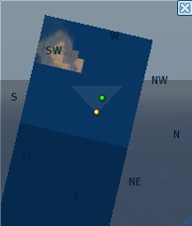

Figure 14: The Mini-Map

16.3 Landmarks
If you wish to visit a landmark in your Inventory, double-click on the landmark description and then choose Teleport. Alternatively, right-click on the landmark description and choose Teleport.

It is good practice to keep a record of places that you have visited and which you may wish to visit again. To do this, select World / Create Landmark Here from the Main Menu. This will automatically add the co-ordinates of your current location to the Landmarks folder in your Inventory.

- See this YouTube SL tutorial on Landmarks and Teleporting:
http://www.youtube.com/watch?v=HL5aqEERlrI

17. Searching
If you wish to search for something in SL, use the Search button at the foot of the SL screen for general searching and the Search button within the World Map for finding locations. You can search for a variety of different things in SL. You will probably want to search mainly for Places, People or Groups – click the appropriate tab in the Search window, or just click the All tab. Enter what you are searching for in the search box.

18. Changing your appearance
You can find a selection of items of Clothing and Body Parts in the Library folder of your Inventory. To attach an item of clothing from your Inventory to your avatar, right-click on the selected item in your Inventory and choose Wear. To remove an item from your body, right-click on your avatar and choose Detach (e.g. for hair) or Take Off (e.g. for clothing). You can also use your mouse to drag and drop an item of clothing or body part or from your Inventory directly onto your avatar.

You can build up a collection of new clothes and body parts in your Inventory by purchasing them in a shop, by picking up freebies in various locations in SL, or from friends who are willing to give you copies of their items. It makes sense to create separate folders in your Inventory for different sets of clothes and hair styles. You can then quickly change a whole set of clothes by right-clicking on the folder name and choosing Replace Outfit. You can also drag different items of clothing from your Inventory on to your avatar.

If you wish to change the shape and look of your avatar you right-click on your avatar’s body and then select Appearance from the pop-up pie menu. The camera angle will change, turning your body round to face you and a set of menu sliders will appear that enable you to configure your appearance: your body shape, your skin colour, eyes, hair and clothing. It is also possible to purchase ready-made body shapes and skins in shops in SL – or pick them up free of charge in various locations.

Any changes that you make to your appearance are stored when you click on Save. Click on Close and your avatar will appear in your regular view of SL, complete with your alterations. However, there is a possibility that you may overwrite items of clothing or body parts that you wish to keep. A better option is to select Make Outfit option from the foot of the Appearance menu and create a complete set of clothes, body parts, hair style, etc under a new name. The new outfit will be stored in your inventory in a new folder under the name that you choose for it.

If you are not certain which items your avatar is currently wearing then open your Inventory and type WORN in the box at the top of the Inventory menu. This will bring up a list of all the items of clothing, jewellery and body parts that your avatar is currently wearing.

See this YouTube SL tutorial on changing your appearance:
http://www.youtube.com/watch?v=GqbuMi5N97c

19. Taking snapshots
Click on the Snapshot button at the foot of the SL screen. This enables you to take a snapshot of the view that you can currently see in SL. Three choices will appear:

- Send via email
- Save to your inventory (L$10)
- Save to your hard drive

Check Save to your hard drive and click on the Save button. A new window will pop up asking you to give the snapshot a name and in which folder you want it to be saved on your hard drive. Complete this information and then click on Save.

If you want to send someone a copy of the picture check Send via email and then click on the Send button. A new window will pop up. Enter the email address of the recipient and type a message to accompany the snapshot. Click on the Send button. This will cause the message and an image file to be sent to the recipient via their normal email system. You can also send snapshots to yourself.

If you choose to save the Snapshot to your Inventory you have to pay L$10 for this privilege! So make sure you have money in your account: see Section 14.

20. Building and editing objects in a sandbox
Building and editing objects that you have created yourself is one of the most exciting and challenging aspects of SL. The process is quite complex and is best explained by a face-to-face demonstration or a video tutorial, so no attempt is being made to describe it fully in this text. Here are the basics:

- First, you need to find a Sandbox, which is an area in which you can create and edit objects. It’s a temporary area and anything that you create in a Sandbox will be deleted and returned to your Inventory after a certain number of hours. A 3-Hour Sandbox is located next to video booths on EduNation II Island.
http://slurl.com/secondlife/EduNation%20II/192/168/22
This YouTube SL tutorial explains the concept of a Sandbox:
http://www.youtube.com/watch?v=b-JNQsI_KAI

- Click on the Build button at the foot of the SL screen. This will cause a pop-up window, which is used for building and editing objects, to appear. You will notice that the cube icon in this window is highlighted.

- Your cursor has now been transformed into a magic wand. Move the cursor into an empty area of the Sandbox and left-click with your mouse. A cube should now appear on the ground. The cube can now be edited and used to create other objects out of it. From this point on I shall demonstrate face-to-face in my workshop how the cube can be transformed into another object.

Have a look at:

- This YouTube SL tutorial, which explains building basics in Second Life:
http://www.youtube.com/watch?v=szAbCGbqYEI

- The video training materials at Russell Stannard’s website under the heading Second Life 2. These videos make use of the Camtasia screen capture software, with voiceovers:
http://www.teachertrainingvideos.com

21. Vehicles
There are several types of vehicles available in SL: cars, motorbikes, cycles, boats and even flying carpets!

If you see a boat in one of the EduNation canals, help yourself to a paddle, right-click on the boat, select Ride and use the arrow keys or onscreen Movement Controls to propel it. You can leave the boat by clicking on Release Keys or Stand Up – but be careful when you do this as you may fall into the water if you are too far from land!

There is go-cart in the Library folder in your Inventory.
- Open your Inventory and type Kart in the search field at the top of the pop-up window.
- You should find Kart 1.0 in the Library folder of your Inventory.
- Drag Kart 1.0 onto the ground near your avatar.
- Right-click on the go-cart and select Ride.
- Have fun, but don’t crash!

See this YouTube SL tutorial on driving a vehicle:
http://www.youtube.com/watch?v=_ISCZ7hTldk

Another way of getting around is on horseback. You can buy a horse at the Lone Start Ranch:
http://slurl.com/secondlife/Equus/180/175/25

22. Holodecks
Initially, a holodeck is not an easy concept to grasp, but once you have seen how a holodeck works then it should become clear to you what it is and how it can be used. The term holodeck derives from the Star Trek series, in which the holodeck is depicted as an enclosed room where realistic simulations can be created both for training and for entertainment. Holodecks in Second Life fulfill more or less the same functions. Think of them as mini-simulations within the Second Life virtual world simulation as a whole.

There are three holodecks in the EUROCALL/CALICO HQ, each of which uses the Horizons system:

- One holodeck can be found on the roof of the EUROCALL Building. You fly up to the roof or teleport there via the teleporter system.

- Another holodeck is at ground level on the CALICO side of the joint HQ

- A third holodeck is located on the Skydeck, which is 2000 metres high in the sky and accessible only via the internal teleport system.

A Notecard containing instructions on how to use the Horizons system can be obtained by clicking on the cube labelled Click here for holodeck instructions next to the EUROCALL/CALICO Welcome Pavilion.

Initially, all you will see that indicates the presence of a holodeck is a round “eye” with a blue centre, the so-called rezzer. If the rezzer is not visible then type show in text chat. Stand close to the rezzer and left-click on it. This will cause a pop-up menu to appear. Choose Scenes from the menu, and then choose one of the simulations, for example the Dining Room scene. You should then find yourself standing in a simulation of a dining room in which you can move around in the same way as you move around in Second Life in general, but you are actually encased within a cube. Type clear in text chat to remove the simulation and then go through the same selection process again, choosing a different scene.

Holodecks make it easy to set up facilities for teaching and training events. One advantage of doing this is that the facility can be located a long way from ground level so that uninvited visitors do not stumble into it accidentally – e.g. the Skydeck in the EUROCALL/CALICO HQ – and it is also completely out of earshot from the ground. There is already a wide range of holodeck scenes that can be used for teaching foreign languages, e.g. a hotel lobby or a restaurant in which students can act out different roles, and also shops and markets. Having the scenes available as holodeck scenes means that they can be set up instantly in any location. Such scenes may, of course, be found in various locations in SL, but one has to look for them and they are usually public, meaning that anyone can walk in at any time, which may not be desirable in a teaching session. The Horizons system allows the scenes to be set up almost anywhere, either within the Horizons rezzer or independently.

An alternative way of instantly generating scenes for teaching or training events is to build the scenes with a so-called packaging tool, e.g. the Builder’s Buddy. The Builder’s Buddy enables you to create a scene, e.g. a market scene consisting of a collection of individual items and then pack them in a box, which can be stored in your inventory and unpacked whenever you need them. All the items automatically fall into the right place within the scene when they are unpacked. An example of a Builder’s Buddy scene can be found the Resources Centre, labelled Furnished Cabin, which you can “buy” for L$0. The cabin will be added to your Inventory and then you can go a Sandbox and unpack it.

23. Giving things to other avatars
It is likely that you may wish to give something to another avatar in SL from time to time, for example an item of clothing, a notecard or a landmark of a place you have visited.

This YouTube SL tutorial explains how you can give something to someone who is nearby, i.e. whom you can see on your SL screen:
http://www.youtube.com/watch?v=S0WzckFdsos

This YouTube SL tutorial explains how you can give something to someone who is at a remote location or who is not logged on to SL:
http://www.youtube.com/watch?v=kxCBXAWsLhw

If another avatar gives something to you then a pop-up window will appear, offering you the choice of accepting their gift or rejecting it.

24. SLURLs

24.1.1 What is a SLURL?
A SLURL is the Second Life equivalent to a URL, being a link or landmark to a location in SL. If you paste a SLURL into your browser, or if you click on a SLURL on a Web page or in an email message, it will open the SL website inviting you to teleport to the location. If you accept the invitation to teleport, the SL software will open, inviting you to log in, and you will then be teleported directly to the location.

You can also send a SLURL in an IM (Instant Message) to an individual or a group of people to tell them about a location. They can then click on the SLURL rather than having to request a teleport from you. It will bring the World Map up for them along with the option to teleport.

24.1.2 How do I create a SLURL?
You can make a SLURL by being at the location you want to refer to and then clicking on the Map button at the bottom menu. The World Map will appear with a button that says Copy SLURL to Clipboard. Click on this button and you can then paste the SLURL into an email, Notepad, a Word document etc.

25. Further tutorial materials
- Dennis Newson’s introduction to Second Life for beginners:
http://dennisintro2sl.pbworks.com
The introduction contains a useful alphabetical list of key commands in Second Life, with screenshots of the menus in which they can be found:
http://dennisintro2sl.pbworks.com/Alphabetical-list-selected-tabs-with-links

- The Orientation Garden on Angel Learning Isle has a series of posters covering the basics of SL and a useful glossary of SL terminology:
http://slurl.com/secondlife/ANGEL%20Learning%20Isle/72/94/28

- Two excellent sets of video training materials on Second Life have been produced by Russell Stannard. These make use of the Camtasia screen capture software, with voiceovers, and can be found at:
http://www.teachertrainingvideos.com/second1/index.html
http://www.teachertrainingvideos.com/second2/index.html
- Getting started in Second Life: The first part of this JISC PDF document covers the basics of Second Life and the second part focuses on the more advanced skills of building and scripting, designing courses in Second Life, as well as offering useful practical advice on setting up Second Life in an educational institution: http://www.jisc.ac.uk/publications/documents/gettingstartedsecondlife.aspx

- SL staff have produced a series of video tutorials covering a wide range of activities and skills you need in SL:
http://wiki.SecondLife.com/wiki/Video_Tutorials

- 30 (and more) things every newbie should know before starting Second Life: http://tinyurl.com/kw3ema

- There is a YouTube playlist Second Life Tutorials here:
http://www.youtube.com/view_play_list?p=9089DEA31F969138
Many other video tutorials submitted by the public can be found in YouTube. Search for keywords: http://www.youtube.com

26. Copyright
© Graham Davies 2010 under a Creative Commons Attribution-Noncommercial-No Derivative Works 2.0 UK, England & Wales Licence.

